Section 0: Introduction Of argon2 :
Argon2 was the winner of the Password Hashing Competition (PHC) in July 2015. This global, open competition aimed to identify a next-generation password hashing standard that was resistant to modern hardware acceleration (like GPUs and ASICs).

It was designed by Alex Biryukov, Dmitry Khovratovich, and Daniel Dinu from the University of Luxembourg.

Section 1: How does actually Argon-2 work:

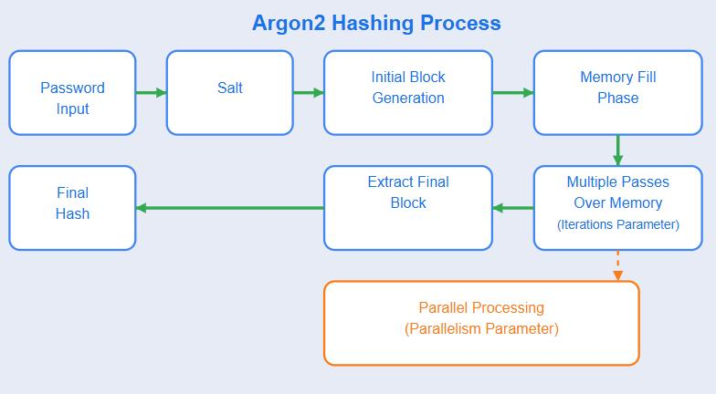
Firstly, Argon-2 is a memory heavy Algorithm. Let us understand what memory heavy is:
Initial Algos like MD-5 and SHA- families solved one problem, which was that the math problem required to be solved consumed huge space in the cpu, but the main issue still was the GPU which could solve these problems billions of times faster. So Argon-2 solves this problem by expanding the amount of space utilized in the RAM of the devices used to resolve the passwords which increases the time required to solve the problems significantly. How?? Let us understand now,

Firstly, the algorithm:
there are 3 main parameters in Argon-2:
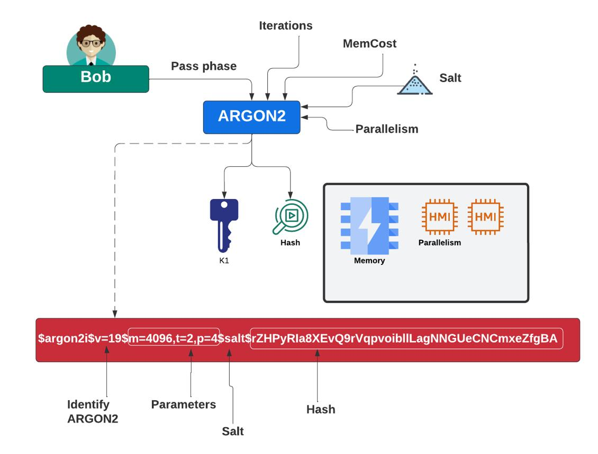
Argon2 hashing process showing input parameters (memory cost, time cost, parallelism, and salt) and final hash generation.

The diagram illustrates how Argon2 takes the password along with parameters such as memory cost, iterations, and salt, and processes them through multiple phases to generate a secure hash. It also shows how the final hash contains all parameters and salt, making verification possible.
memory cost (m) : Defines the amount of RAM (in kilobytes) the algorithm will occupy.
time cost (t) : The number of iterations (passes) the algorithm takes over the memory. Higher t increases the time a hacker needs for one guess.
Parallelism (p): The number of threads (lanes) used.
salt (s) : A unique random string that ensures two identical passwords result in different hashes, defeating "Rainbow Table" attacks.

(Rainbow-table Attacks: the hacker pre-calculates the hashes for billions of common passwords (like "123456" or "password") and stores them in a table. If they steal a database of hashed passwords, they just look up the hash in their "cheat sheet" to find the original password instantly. --- solution is salt.)

Internal Algo:
The algorithm mixes the password, salt, and settings (like how much RAM to use) into an initial 64-byte block called H0. This acts as the "DNA" for everything that follows.

Argon2 reserves a large "grid" in your computer's RAM. This grid is divided into Lanes (for parallel processing) and Blocks (small 1KB chunks of data).

The algorithm fills the grid by "mixing" blocks together. To create a new block, it takes a 2 previous blocks, then scrambles them together using a function called G(uses Blake2b Quarter rounds). It then takes XOR of last few blocks to produce a final password hash.

There are 3 main variants of argon2:
Argon2d (Data-Dependent): It looks at the bits of the secret password itself to choose the next memory address. Because the path is determined by the secret data, it is totally unpredictable. Specialized hardware (like GPUs) hates this because they can't "pre-load" data; they have to wait and see where the algorithm jumps next, which makes them very slow.
Drawback: Timing Attack: Because the jumps depend on the secret, a "spy" on the same server can measure how long it takes the CPU to grab data from RAM. Those tiny timing differences (measured in nanoseconds) can leak clues about the password bits.
Argon2i (Data-Independent): It ignores the password bits and uses a fixed mathematical formula to decide the jumps. The path is the same every single time. Since the memory path never changes, a "spy" watching the CPU cache or timing learns absolutely nothing about the password.
Argon2id (Hybrid): This is the modern standard. It uses the "i" approach for the first part of the memory to protect against spies, then switches to the "d" approach to maximize resistance against specialized hardware.

Section2: Where is/was it used?

Linux Full Disk Encryption (LUKS2) : - When you set a password to encrypt your hard drive on Linux using LUKS, the key used to actually encrypt the disk is derived from your password using Argon2.Below Image shows that the primary security layer is using Argon2id.

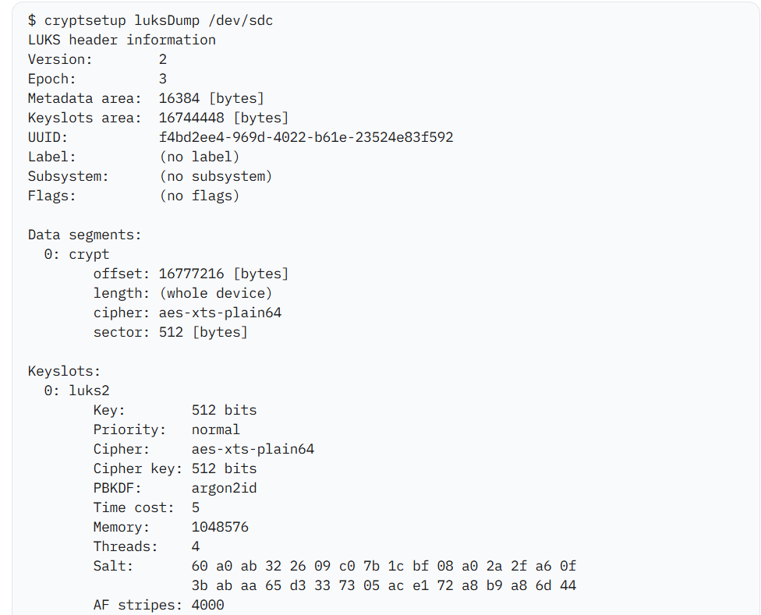
Source: iBlue Team
Link: LUKS, hashcat, and hidden volumes

Password Managers like Bitwarden(one of the most popular cloud-based password managers).
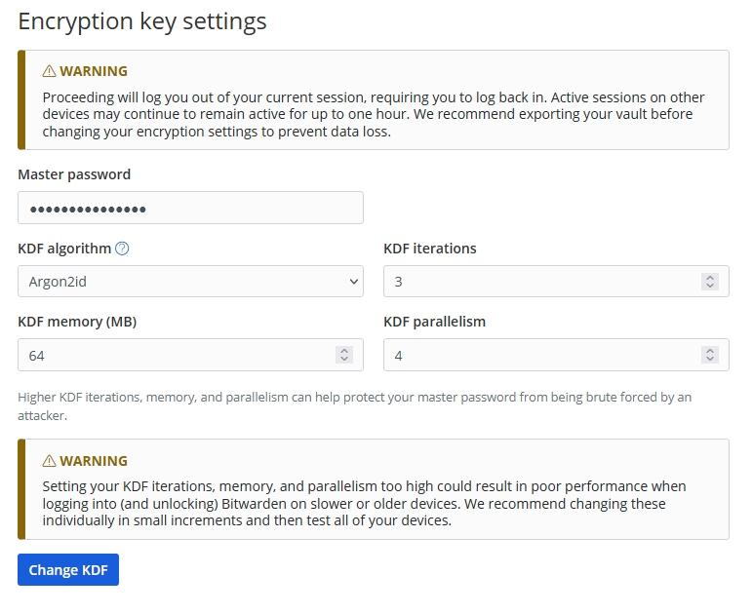

Python: The argon2-cffi library is the standard used for modern authentication in Django and Flask.

Fun Fact: OWASP (the global authority on web security) explicitly lists Argon2id as the number one choice for password storage in its cheat sheets.

Section 3: Time & Speed Analysis

Objective:
To evaluate the execution time of Argon2 under different parameter configurations and analyze how memory cost and time cost influence hashing performance.

Here, we measure the amount of time it takes get a hash for a password.

Hardware Used: Laptop: HP-Victus
Library: Python-3.7.9 argon2-cffi
Input Data: “Daiict-2026”

Experiment-1:
Here, we check how changing the memory and time cost can affect the time required for computing hash for a single password.

Observation:
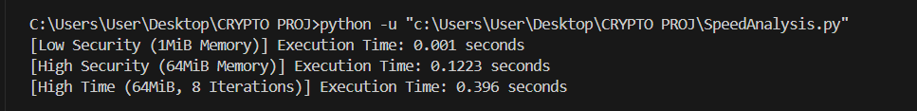
Analysis :

Memory (MiB) | Time Cost | Time Taken (sec)
1 | 2 | 0.001
64 | 2 | 0.1223
64 | 8 | 0.396

When we increased the memory from 1Mib to 64 Mib in second scenario, we saw that the time required to rehash the password increases significantly. This confirms Argon2’s “Memory Hardness” property, i.e as we increase the amount of space our algorithm need in the RAM of the device, the time required to calculate the password increases significantly.

On the other hand, when we increase the number of iterations from 2 -> 8, the amount of time the algo takes get tripled nearly. So. We reach to the conclusion that by varying the above 2 parameters we can increase the time it takes for the attacker to crack the password.

Experimenet-2 :
Here ,we are calculating the time it takes for Argon2 to calculate the has for a 1,100 and 1000 passwords under 2 conditions :

Memory (MiB) | Time Cost | Parallelism(p)
1 | 2 | 2
64 | 3 | 4

Observation:
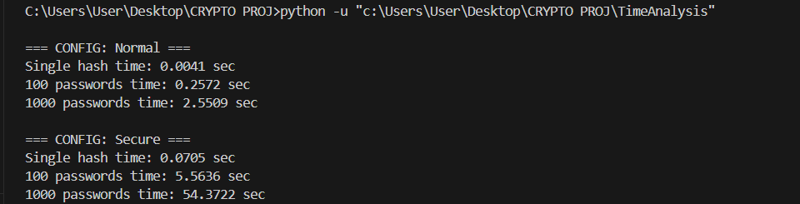
From the above result, increasing memory and iteration parameters significantly increases hashing time, making large-scale attacks computationally expensive.

Analysis:

The following table summarizes the observed execution times for different configurations.

Configuration | Single Hash (sec) | 100 Passwords (sec) | 1000 Passwords (sec)
Normal (1MiB, t=2) | 0.0041 | 0.2572 | 2.5509
Secure (64MiB, t=3) | 0.0705 | 5.5636 | 54.3722

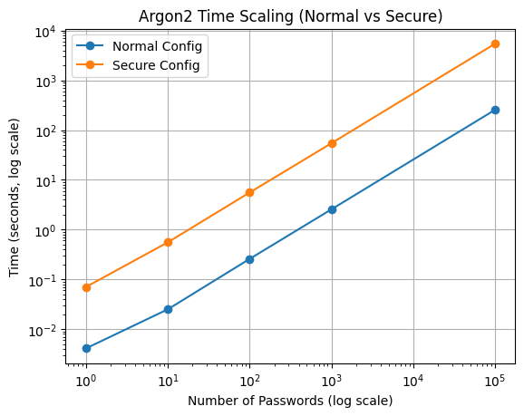
The graph shows that both normal and secure configurations scale linearly with the number of password hashes. However, the secure configuration consistently requires significantly more computation time than the normal configuration.
This indicates that while the growth rate remains similar, the absolute computational cost per guess is much higher in secure settings. As a result, large-scale attacks become significantly more expensive and time-consuming.

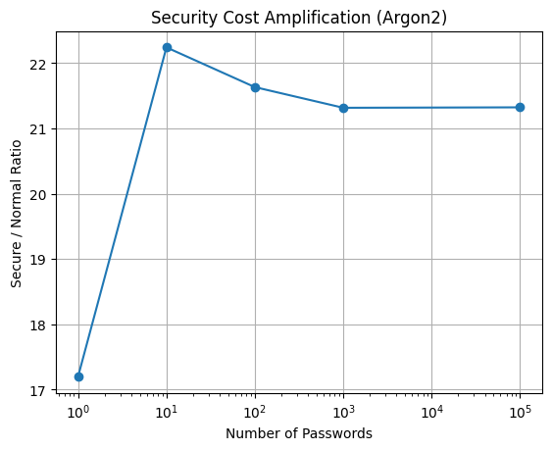
The ratio graph shows that secure configuration consistently requires significantly more computation than the normal configuration, demonstrating increased attack cost.
The experimental results clearly demonstrate the impact of parameter tuning in Argon2. When using the normal configuration (low memory and iteration count), hashing is extremely fast, making it suitable for responsive user authentication systems.
However, when switching to a secure configuration (higher memory and iterations), the time required increases significantly. For example, hashing 1000 passwords increased from approximately 2.55 seconds to 54.37 seconds, representing more than a 20× increase in computational cost.
This confirms Argon2’s memory-hard property, where increasing memory usage directly increases computation time. Additionally, the linear scaling observed between 100 and 1000 passwords shows that large-scale attacks become impractical as the cost per guess increases.
Thus, Argon2 provides a tunable balance between security and performance, allowing systems to adjust parameters based on required security levels. Also, from an attacker’s perspective, this increase in hashing time directly reduces the number of guesses per second, thereby significantly increasing the total cracking time.

To understand the real-world impact of hashing time on attack feasibility, we analyze how it affects an attacker’s guessing capability.
According to usability studies by Jakob Nielsen, an ideal response time for user interaction is approximately 0.5 seconds. This provides a balance between security and user experience.
The time required to crack a password can be modeled as:
Cracking Time = (K / G) × Th
where:
K = total key space (2^E, where E is password entropy)
G = guessing speed of the attacker (guesses per second)
Th = time required to compute a single hash
For fast hashing algorithms such as MD5, where Th ≈ 0.0000001 seconds, an attacker can attempt up to 10 billion guesses per second. However, when Th is increased to approximately 0.5 seconds (as in secure configurations of Argon2), the attacker’s guessing rate drops drastically to about 2 guesses per second.
This demonstrates that increasing hashing time significantly reduces the effectiveness of brute-force attacks. However, excessively increasing this time may degrade user experience, so a balance must be maintained.

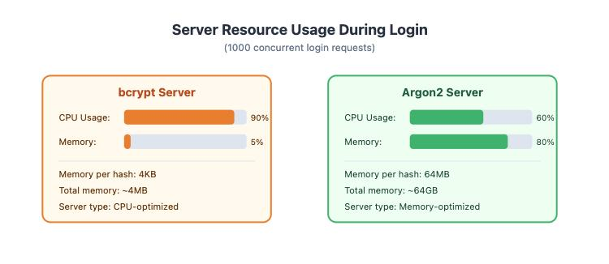
Source: Adapted from Argon2 RFC 9106 and password hashing benchmark studies (Biryukov et al., 2016).

The figure compares resource usage between bcrypt and Argon2 under high load conditions. While bcrypt primarily increases CPU usage, Argon2 significantly increases memory usage. This high memory requirement limits parallel execution on GPUs, making Argon2 more resistant to large-scale brute-force attacks.

Section 4: Security Analysis

Objective: Evaluate how secure Argon2 is against different types of attacks.

EXPERIMENT 1 — BRUTE FORCE COST (TIME PER GUESS)
Objective : Measure how slow one guess is → attacker speed

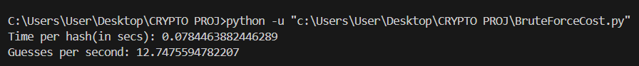
  - Parameters: t=3 and m=1Mib

The experiment shows that Argon2 significantly limits the number of guesses per second, making brute-force attacks inefficient. Compared to fast hashing algorithms like MD5 (which allow billions of guesses per second), Argon2 reduces the guessing rate to only a few attempts per second.

EXPERIMENT 2 — SALT VERIFICATION EXPERIMENT
Objective: To experimentally verify that Argon2 automatically incorporates salting and to observe its effect on hash uniqueness and security.

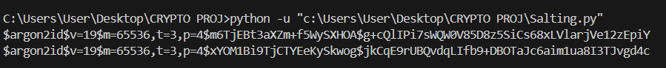
A salting verification experiment was conducted using Argon2 by hashing the same password multiple times with identical parameters. As shown in the output, each hashing operation produced a completely different hash value despite identical inputs.
This behavior confirms that Argon2 automatically generates a unique random salt (which is stored within the hash output, eliminating the need for separate storage) for every hashing operation. The salt is embedded within the final hash output, ensuring that identical passwords do not result in identical hashes. This prevents attackers from using precomputed tables such as rainbow tables and significantly increases resistance against large-scale attacks.

EXPERIMENT 3 — MEMORY HARDNESS EFFECT
Objective: Increase memory → observe time increase
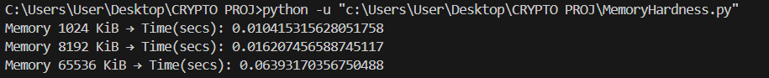
  - Parameters: t=3

The results show that increasing memory cost increases computation time, confirming Argon2’s memory-hard nature.

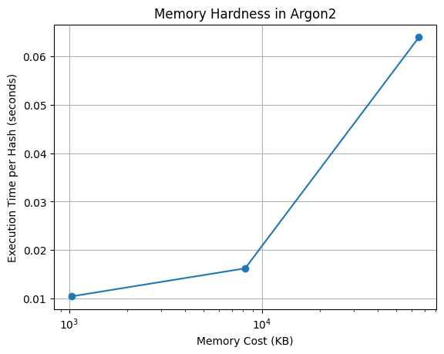
The graph demonstrates that increasing memory cost leads to higher execution time, validating the memory-hard design of Argon2.

Conclusion:

Security Property | Status | Proof
Collision Resistance | Strong(might occur after 2^128 hashes) | Argon2 uses a secure hashing function called Blake2b(256 bit hashes) internally, which is designed to minimize the possibility of two different inputs producing the same hash, thereby providing strong collision resistance.
Brute-force Resistance | Very Strong | Verified via time-per-hash experiment
Rainbow Table Resistance | Strong | Verified via salting experiment
GPU Resistance | Very Strong | Verified via memory scaling experiment
Current Status | Recommended | OWASP (as stated in section -2)

The security of Argon2 was evaluated through both theoretical analysis and experimental validation. The time-per-hash experiment demonstrates that the number of guesses per second is significantly limited, reducing the effectiveness of brute-force attacks. The salting experiment confirms that identical passwords produce different hashes, preventing rainbow table attacks.
Additionally, the memory hardness experiment shows that increasing memory cost leads to a substantial increase in computation time. This limits parallel execution on GPUs and makes large-scale attacks computationally expensive.
These results confirm that Argon2 provides strong resistance against modern attack techniques and is suitable for secure password storage. This makes Argon2 significantly more secure than traditional hashing algorithms such as MD5 and SHA-256.

Section 5: Attack Simulations

Objective: To evaluate the resistance of different hashing algorithms (MD5, SHA256, Argon2) against dictionary attacks using a realistic attacker model.

In this experiment, we simulate an attacker who has:
- A database of hashed passwords
- A wordlist (dictionary of possible passwords)

Attack Process:
- The attacker selects a password from the wordlist
- Hashes it using the same algorithm
- Compares it with the stored hash
- If a match is found → password is cracked

This type of attack is known as a dictionary attack, where pre-defined password lists are used to guess user passwords efficiently.

- Tool Used: Hashcat
- Hardware: Laptop HP VICTUS-i7 GPU (RTX 4050)
- Wordlist: 1000MostCommonPasswords.txt (1000 data points)
- Target Password: hello123
Source of dataset: SecLists Project. “Common Passwords Wordlists.” GitHub Repository. Available at: https://github.com/danielmiessler/SecLists

Experiment 1: MD5 Attack
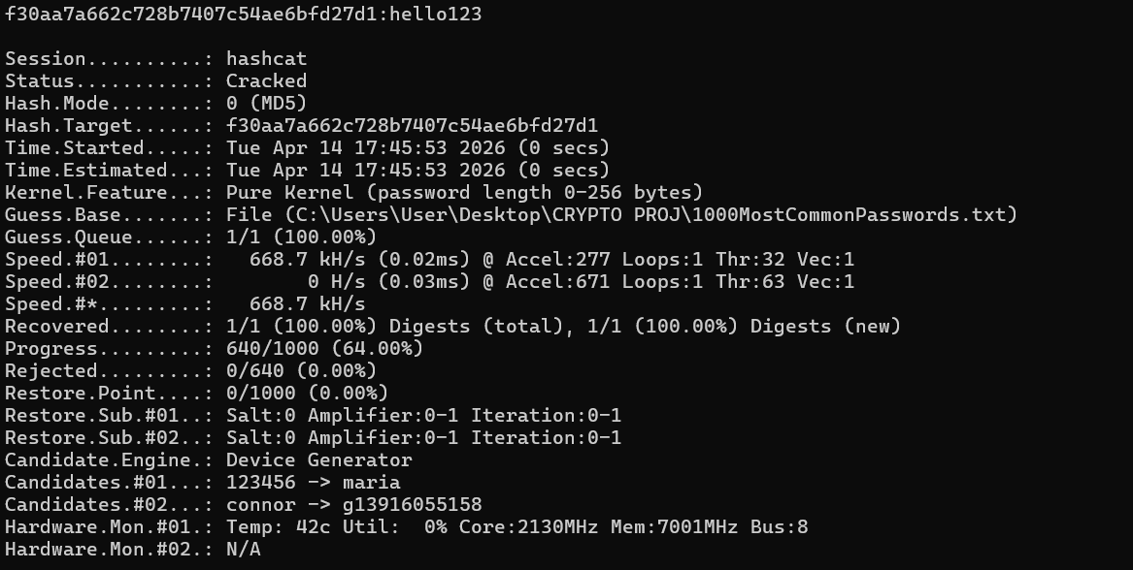

Observation:

- Status: Cracked
- Speed: ~668,700 hashes per second
- Time: ~0 seconds
Conclusion:
The MD5 hash was successfully cracked almost instantly due to its extremely high processing speed. The attacker was able to test hundreds of thousands of guesses per second, making brute-force and dictionary attacks highly effective.

Experiment 2: SHA256 Attack
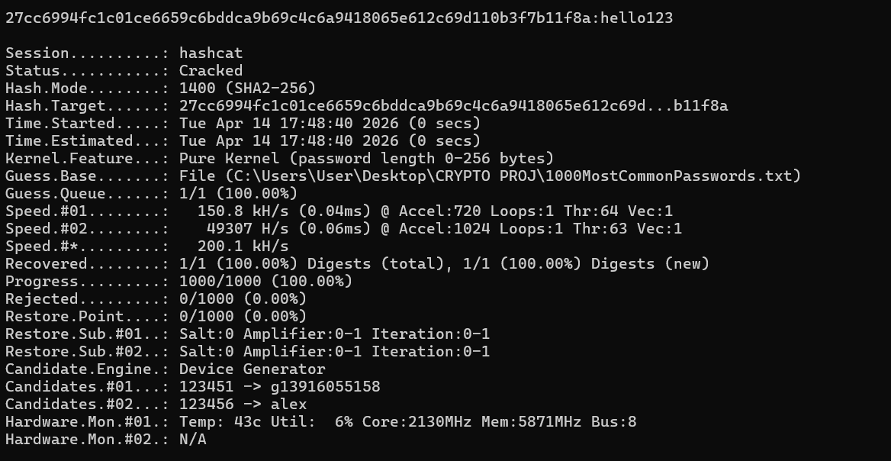

Observation:

- Status: Cracked
- Speed: ~200,100 hashes per second
- Time: ~0 seconds
Conclusion:
The SHA256 hash was also cracked successfully using the same wordlist. Although slower than MD5, it still allows a large number of guesses per second, making it vulnerable to dictionary attacks.

Experiment 3: Arogn2 Attack

Case 1: params: t=3, m=8192 KiB, p=2
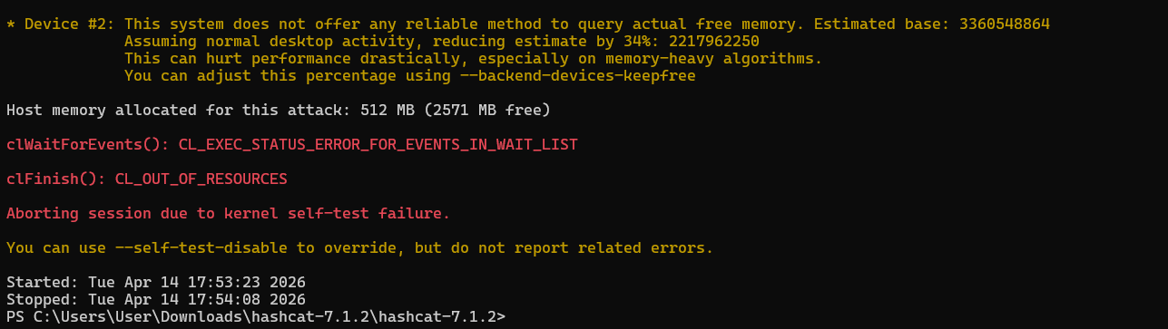

Observation:

- Status: Failed
- Error: CL_OUT_OF_RESOURCES

Conclusion:
The GPU has limited VRAM capacity, which restricts the amount of memory that can be allocated per thread. Argon2 requires a large amount of memory for each hashing operation, leading to high per-thread memory consumption. As a result, the GPU is unable to efficiently execute a large number of parallel threads, making parallel execution significantly constrained or even infeasible.

Now when we use reduced params of params: t=2, m=8192 KiB, p=2 we get
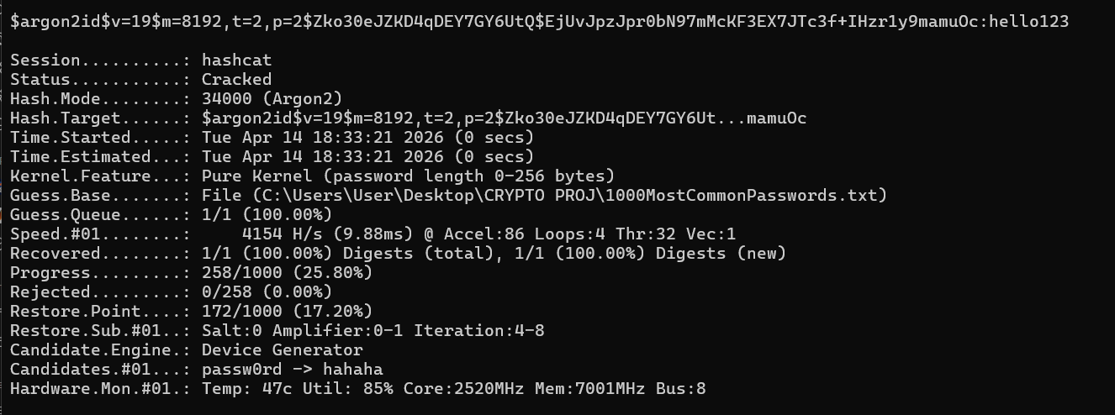

After adjusting parameters and execution settings, the Argon2 hash was successfully cracked. However, the speed was significantly lower (~4000 hashes per second) compared to MD5 and SHA256.
Thus, Argon2 is a memory-hard algorithm, meaning it requires a large amount of memory per hash computation. This prevents efficient parallel execution on GPUs and significantly reduces the effectiveness of large-scale attacks.

Comparative Results:
Algorithm | Speed (H/s) | Result | Security Level
MD5 | ~668k | Cracked instantly | Weak
SHA256 | ~200k | Cracked instantly | Moderate
Argon2(T=3,  m=8192,p=2) | Failed (memory error) | Not cracked | Very Strong
Argon2(T=2,  m=8192,p=2) | ~4154 | Cracked Successfully at lower speed | Very Strong

Scenario-2: In real-world scenarios, attackers often use leaked password databases rather than small curated lists. These datasets contain actual passwords used by users, including common patterns, reused passwords, and predictable combinations.
To simulate a more realistic attack, a leaked-style dataset containing approximately 10,000 passwords was used. This helps evaluate how password patterns influence the effectiveness of dictionary attacks.

- Tool Used: Hashcat
- Hardware: Laptop HP VICTUS-i7 GPU (RTX 4050)
- Wordlist: LeakedPasswords.txt(~10k data points)
- Target Password: hello123

Source for dataset: SecLists Project. “Keyboard Combinations Wordlist.” GitHub Repository. Available at: https://github.com/danielmiessler/SecLists

Experiment 1: MD5 Attack 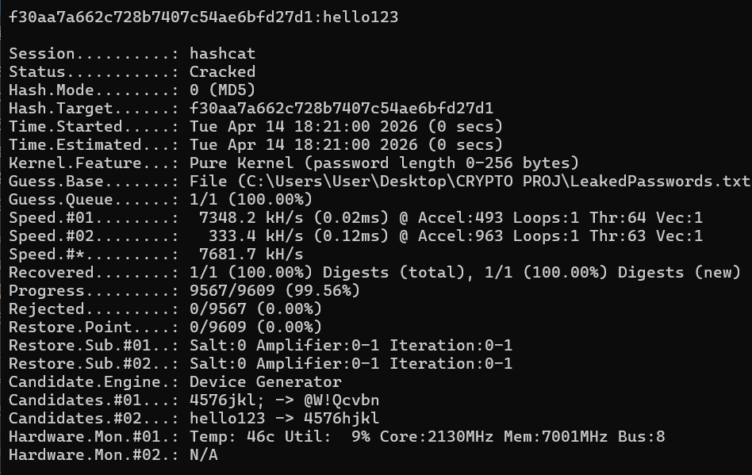

Observation:

- Status: Cracked
- Speed: ~734,200 hashes per second
- Time: ~0 seconds
Conclusion:
Despite the increase in dataset size, the attack remained extremely fast due to the high processing speed of MD5. This demonstrates that increasing dataset size does not significantly improve security when using fast hashing algorithms. Also, Attack success depends more on password position in dataset, not just size.

Experiment 2: SHA256 Attack
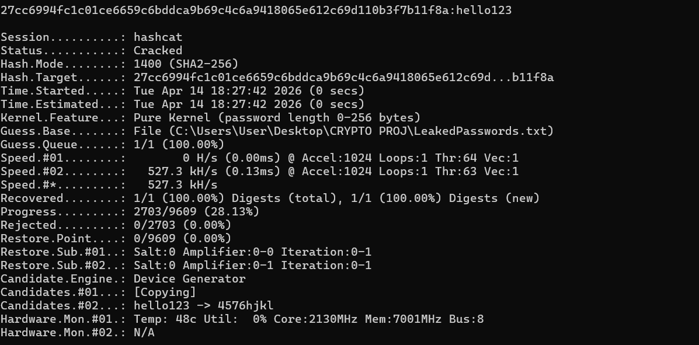

Observation:

- Status: Cracked
- Speed: ~527,300 hashes per second
- Time: ~0 seconds
Conclusion:
The SHA256 hash was successfully cracked using the leaked dataset (~10,000 passwords) at a speed of approximately 527,000 hashes per second. The password was recovered before the dataset was fully exhausted, demonstrating that SHA256 remains vulnerable to dictionary attacks despite increased dataset size.

Experiment 3: Argon2 Attack(params: t=2, m=8192Kib, p=2)
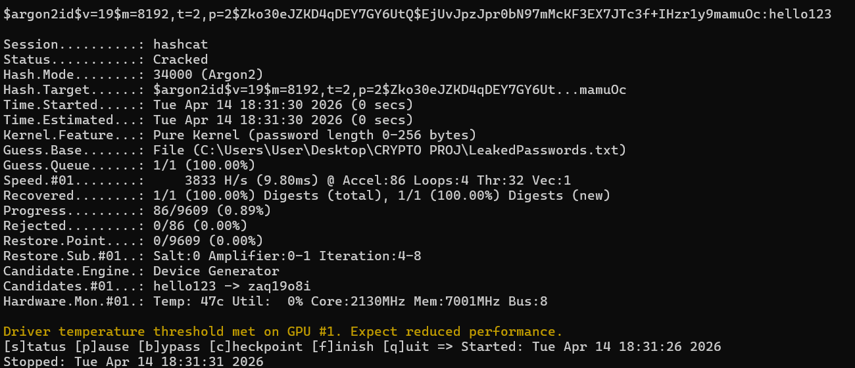

Observation:

- Status: Cracked
- Speed: ~338,3 hashes per second
- Time: Noticeably higher compared to MD5 and SHA256
Conclusion:
The Argon2 hash was successfully cracked using the leaked dataset at a speed of approximately 3800 hashes per second.
When compared with the earlier experiment using the smaller dataset (1000 passwords), the observed speed was approximately 4154 hashes per second under the same parameter configuration.
This shows that increasing the dataset size from 1000 to 10,000 passwords does not significantly affect the hashing speed, as the dominant factor is the computational cost of the Argon2 algorithm itself rather than the number of password guesses.

Algorithm | Speed (H/s) | Result | Security Level
MD5 | ~734k | Cracked instantly | Weak
SHA256 | ~527k | Cracked instantly | Moderate
Argon2 | ~3383 | Cracked Successfully at lower speed | Very Strong

Comparison of Datasets (1000 vs 10,000 Passwords) :
To evaluate the impact of dataset size on attack effectiveness, experiments were conducted using two datasets: a smaller common password list (~1000 entries) and a larger leaked dataset (~10,000 entries).
For fast hashing algorithms such as MD5 and SHA256, increasing the dataset size did not significantly impact the attack speed. These algorithms process hundreds of thousands of guesses per second, allowing attackers to quickly test even large datasets.
In contrast, Argon2 showed consistently low speeds (~4000 H/s for 1000 dataset and ~3800 H/s for 10,000 dataset), indicating that the computational cost per hash dominates the attack performance rather than the number of guesses.
Although a larger dataset increases the total number of attempts, the time per guess remains constant. Therefore, the effectiveness of the attack depends more on hashing speed than dataset size.
Additionally, the position of the password within the dataset plays a crucial role. In both cases, the password was found before the dataset was fully exhausted, demonstrating that attack time is influenced by password ordering as well.

Dataset Size | Algorithm | Speed | Observation
1000 | Argon2 | ~4154 H/s | Slow
10000 | Argon2 | ~3800 H/s | Similar speed
1000 | SHA256 | ~200k H/s | Fast
10000 | SHA256 | ~527k H/s | Still fast

This confirms that dataset size affects total attempts, but hashing algorithm determines security.

Final Thoughts: The attack simulations clearly demonstrate that fast hashing algorithms such as MD5 and SHA256 are highly vulnerable to dictionary attacks due to their high speed. In contrast, Argon2 significantly increases both computational and memory costs, making attacks impractical. The inability of the GPU to handle Argon2 efficiently further highlights its effectiveness as a secure password hashing algorithm. Thus, security of password hashing depends not just on cryptographic strength, but also on computational cost and memory usage — where Argon2 excels.

